Project 1 – Budget Tracker

Waqas Ali

Project Description:

The intent of this project is to develop a program that can keep track of the budget for a whole year. Every month the user will enter his/her data that includes income, expenses, and investments. There are income, expense and investment classes that will keep a log of that data. Budget class will have access to all user’s data through income, expense, and investment classes. There will be manager class as well. Budget class has 8 methods to manipulate user’s data to get useful insights about monthly and yearly budget.

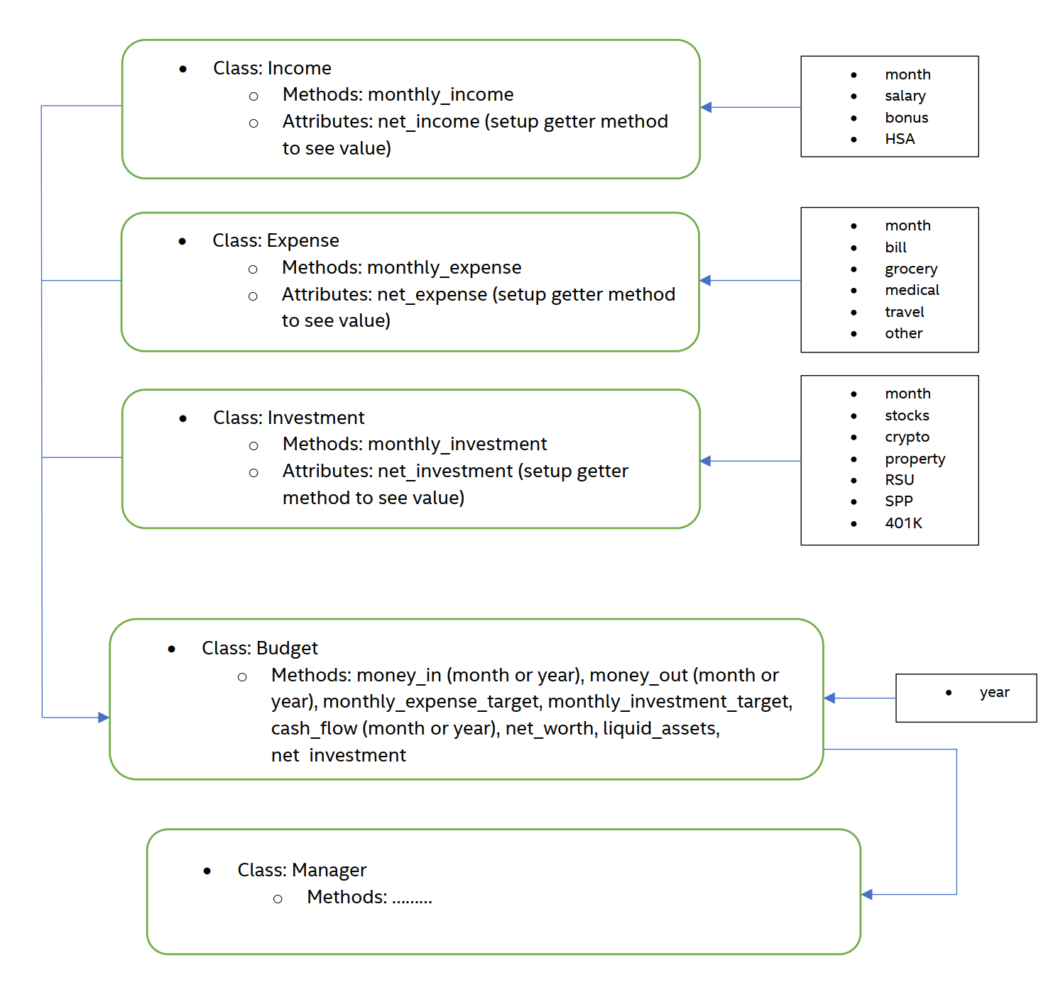

**Framework of Budget-Tracker**

**Framework of Budget-Tracker**

* Class **Income**:The purpose of this class is to keep track of income data of the user. Income data includes salary, bonuses and HAS contributions for every month.
* Class **Expense**: It will keep track of different types of expenses for every month. Expenses include bill, grocery, medical expenses, travel and other exepenses.
* Classs **Investment**: It will keep track of the different types of investememnts, every month. Investements include stocks, crypto, property, RSUs, SPP and 401K contributions.
* Class **Budget**: The goal of this class is to use data from Income, Expense and Investement classes and create useful insights for the user about his cash inflow, cash outflow, net worth, liquid assets and other useful trends. There will be 8 methods in this class for this purpose. These methods are:
  + money_in(): This will calculate the total income of the user
  + money_out: This will calculate the total expenses
  + monthly_expense_target(): This will determine the monthly expense target, based on a set goal.
  + monthly_investment_target(): This will determine the monthly investment target, based on a set goal.
  + cash_flow(): It will tell the overall cash flow.
  + net_worth(): This will display the net worth of the user.
  + liquid_assets(): It will tell the net worth of liquid assets.
  + net_investment(): It will tell the net investment of the user.

* Class **Manager**
* stocks
* crypto
* property
* RSU
* SPP
* 401K